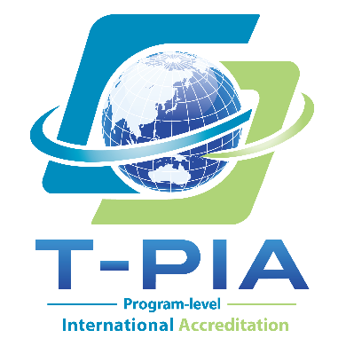
--------- TWAEA Program-level International Accreditation ---------
APPLICANT PROGRAM INFORMATION SHEET
[Please complete a separate sheet for each applicant program. Before submitting the completed form, please remove all gray instructional text enclosed in square brackets and all example text.]
Part I. Basic Information
Program Name
Degree(s) Awarded | [Please provide the official English title of the degree awarded, e.g., Bachelor of Arts, Master of Science, or Doctor of Philosophy.]
Program Level  (Select all that apply) | ☐ Bachelor's Program  ☐ Master's Program  ☐ Doctoral Program  ☐ Other Degree-Awarding Program:
Year(s) of Establishment by Program Level | [Please indicate the year in which each selected program level was established.]  Example: Bachelor’s—1999; Master’s—2018; Doctoral—2022.
Reference Date for Enrollment and Faculty Data | [Please indicate the reference date for the latest available data reported below.]
Current Student Enrollment by Program Level | [Please report enrollment at each selected program level as of the reference date above.]
Full-time Faculty Members Assigned to the Program | [Please report the total number of full-time faculty members assigned to the program as of the reference date, counting each member only once even if they teach at multiple program levels.]
Program Website (English-language page, if available) | [Please enter URL.]
Language(s) of Instruction | [If more than one language is used, clearly indicate the percentage of credits delivered in each language for required and elective courses separately.]  Example:  Required courses—English 70%; local language 30%.  Elective courses—English 50%; local language 50%.
Part II. Accreditation Information
Previous Accreditation Status | ☐ None  ☐ Previously accredited [If selected, please complete the fields below.]  - Most Recent Accreditation Result:  - Accrediting Agency:  - Validity Period:
Accreditation Track Requested (Select one) | ☐ General Program Accreditation  ☐ English-Medium Instruction (EMI) Program Accreditation  [Please select the applicable accreditation track. The selected track will determine the accreditation standards and review focus applied to the program.]
Preferred Timeframe for the Site Visit*
Preferred Date for Receiving the Accreditation Result
Proposed Additional Indicator(s)**
* The site visit includes a tour of relevant facilities and classroom observation. At least one regularly scheduled discipline-specific course should be available for observation. For EMI Program Accreditation, the observed course should be delivered in English. The visit should therefore normally be scheduled during the teaching semester rather than during winter or summer breaks.
** If the applicant program wishes or is required to propose additional indicators beyond those specified in the applicable T-PIA Accreditation Standards—for example, due to local regulatory requirements or specific institutional or program development needs—please list them in the space provided. If none are proposed, please enter “None.” All proposed additional indicators are subject to review and confirmation by the Review Team.
Part III. Brief Introduction
[Please provide a concise introduction to the program, including its background, educational objectives, disciplinary or professional orientation, distinctive features, and other characteristics relevant to the selection of the Review Team. For EMI Program Accreditation, also briefly explain the rationale, scope, and implementation of EMI.]

Program Leader:
Title:
Email:
Date of Submission:

